|  |
| --- |
|  |
| Fuzzy Critter Battles |
|  |

|  |
| --- |
| Team Name: The Nikola Tesla’s Ryan Babcock, Stacy Carlson, and Laura Humphreys  3/16/2015 |

Table of Contents

**Project Description3**

**How the Game is Played3**

**Design Patterns Used4**

**UML5**

# Project Description

Our project is a dungeon crawler with two different dungeon sizes and three different dungeons. The player chooses a party of three cute critters and navigates a dungeon. The player randomly comes across parties of three scary critters that they have to battle to the death. They also find items, including robots which they must have to the exit the dungeon. To win the game, the player has to navigate all three dungeons without being killed by the scary critters.

# How the Game is Played

**Game Set Up**

After entering the game application the player selects the difficulty of the maze from the dropdown of choices and clicks Start Game.

**Choosing the Party**

After the game is started, a screen appears with the cute fuzzy critters to choose from. The player clicks on the pictures of the critters to fill the party. A player may select the same critter multiple times and they may remove critters from the party. There must be three cute fuzzy critters to begin the game. When the player is happy with the party selected, they click done and game play begins.

**Moving Around the Maze**

The player clicks on the arrow buttons to move around the maze. The path in the first dungeon is designated by grass, the walls are designated by bricks, the entrance is a wooden door, and the exit is a yellow door. The path in the second dungeon is designated by asphalt, the walls are designated by rooftops and lawns, the entrance is a silver manhole cover, and the exit is a yellow manhole cover. The path in the third dungeon is designated by sand, the walls are designated by waves, the entrance is a pink beach bungalow, and the exit is a yellow beach bungalow.

**Picking Up Items**

Items and the robot are placed at random. The player must explore the dungeon to find items. A window pops up when an item or robot is found. See Moving Around the Maze.

**Battling a Scary Critter**

If a scary critter party is encountered a window pops up. The player can attack a scary critter, defend against an attack which causes half damage on the next attack, use an item, or use their special attack ability.

**Losing the Game**

The player loses the game if all of the cute fuzzy critter party members are defeated by the scary critters.

**Winning the Game**

The player wins the game if they reach the exit of the third dungeon with all of the robots.

# Patterns Used

**Decorator**

* **Robot Decorator:** We used Decorator to add Robots to our characters because we wanted to add extra abilities to our characters at runtime.

**Factory**

* **Action Factory:** We used Simple Factory for our actions in order to simplify the creation of actions and quickly swap them at runtime.
* **Game Character Factory:** We used an abstract Game Character Factory with concrete Hero and Monster Factories in order to simplify the creation of characters. By using Factory we reduced the dependency on concrete classes.
* **Image Factory:** We used Simple Factory for our images in order to simplify the creation of the multiple images used in the game.

**Mediator**

* **Battle Window:** We used Mediator for our Battle Window because we needed to facilitate communication between many different classes.

**Singleton**

* **Robot Factory:** We used Singleton for the Robot Factory because we only wanted one robot to be awarded per dungeon.

**Strategy**

* **Special Actions:** We used Strategy for our Special Actions because each character had a special action behavior. The behaviors were all different, but all were considered to be of the special action type.

# UML Diagrams

**Decorator**

**Robot Decorator**

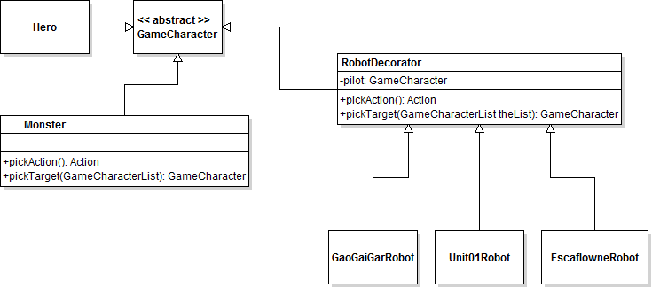

**Factory**

**Action Factory**

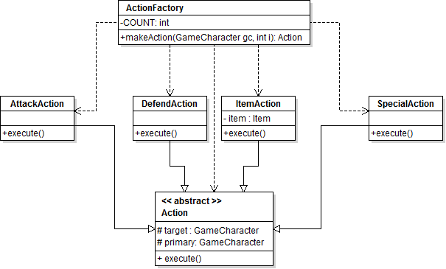

**Image Factory**

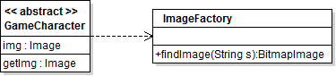

**Game Character Factory**

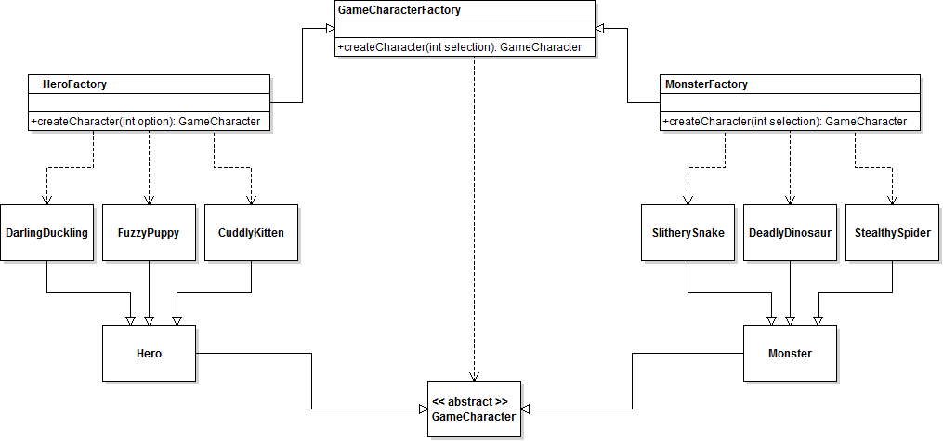

**Mediator**

**Battle Window**

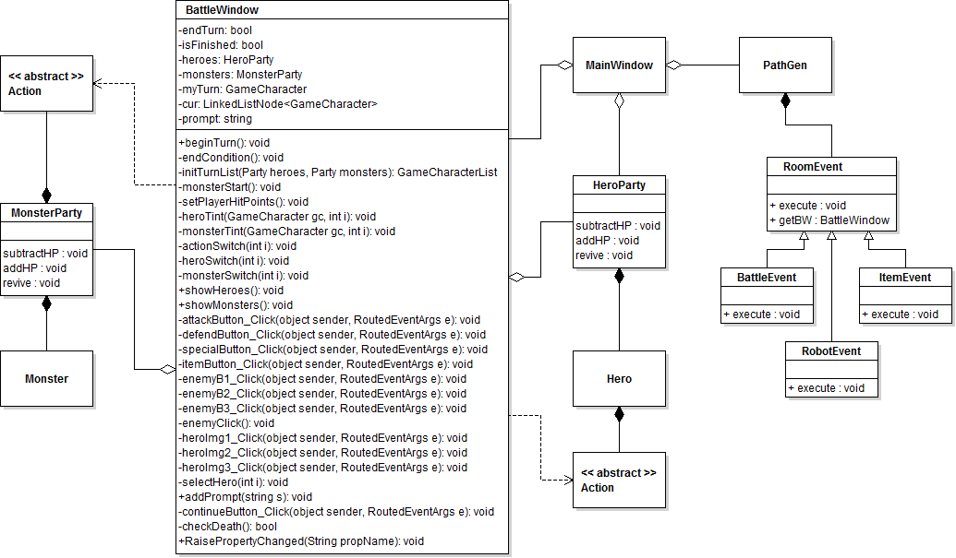

**Singleton**

**Robot Factory**

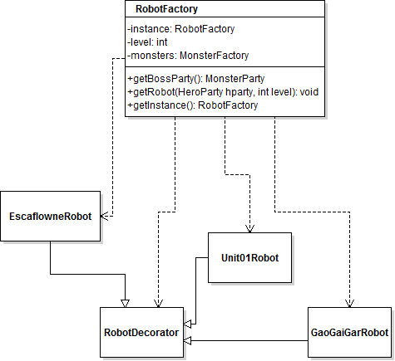

**Strategy**

**Special Actions**

